Educational game analysis

Juan Fco. Losa Márquez
Group 1st DAW
Final Project

Date: 25/03/2021
Table of contents

Introduction 3
Functional requirements 4
Non functional requirements 5
System requirements 5
Use case diagram 6
Activity diagrams 7
Use case Starfleet player 7
Use case Klingon player 9

Introduction
We are going to develop a game called Star Battle. It will have a web version and a mobile version too, so we will need the kind of technology that allows us this versatility.
It will be possible to play with only one device, against an IA, or against other remote contenders via Internet.
We will need a web hosting with a high-bandwidth as we want the Internet games to go smoothly.
Besides, we will use an Oracle database to store users and games, always following data protection regulations.
In a game, there will be two contenders, one will be the Starfleet and the other will be the Klingon Empire. These players may be registered users (they have to log in the application) or guest users.
The registered users will choose whether they are Starfleet or Klingon Empire, but guest users will only be able to choose Klingon Empire. Each contender will have a starship fleet with 6 starships and each ship will have 2 different cannons (laser cannon, plasma cannon, etc.)
First of all, users will choose a level (1,2 or 3) meaning the difficulty of the game.
Each starship will be placed in a coordinate (x, y) of the grid of the game and the game will start.
Each player will alternatively shoot to a coordinate choosing which ship and weapon to use. Each weapon has the option of double power and the damage to the enemy will be the double, however, it means wasting the double of ammunition of the weapon chosen.
Each weapon has a fixed amount of ammunition which is updated each shot. When the ammunition is out, the weapon will not be able to be used again, unless the player is a registered user who has stored points from previous victorious games.
Each ship will have a shield which allows the ship to absorb a number of impacts before being destroyed.
If a ship is not damaged during 10 turns, it will be completely repaired.
In each turn a player shoots, the other checks the damages of the fleet and informs to the contender if it has been damaged or not.
The game continues until one of the fleet is completely destroyed or the Star Fleet surrenders (Klingon Empire never surrenders)
When the game is over, a ranking with the best players will be updated and the winner will have points added to their profile which they will be able to exchange for ammunition in other games.

Functional requirements
- The system will save the data of the users' records, as well as the games in an Oracle database.
- You can start a game not being registered, as a guest, with the particularity of playing only as Glingon.
- At the end of the game, the game data will be compared with the data in the database and a ranking with the best scores will be displayed.
- The system will allow the elaboration and issuance of the regulatory report XX, according to the requirements established in the regulations and applicable law.
- Any data exchange via the internet carried out by the software will be done through the encrypted https protocol.
- The application can be installed on Windows, OSX and Linux, as well as android and IOS.

Non functional requirements
- The system must be able to operate adequately with up to 50,000 users with concurrent sessions.
- System access permissions can only be changed by the data access administrator.
- If security attacks or system breaches are identified, the system will not continue to operate until unlocked by a security administrator.
- The system should provide error messages that are informative and end-user oriented.
- The system must have an online help module.
- The application must have a “Responsive” design in order to guarantee adequate visualization on multiple personal computers, tablet devices and smartphones.
- The system must have well-formed graphical interfaces.

System requirements
- The application will have a high-performance server for proper operation.
- The data will be saved on a remote server with security protocols that ensure its integrity.
- The internet connection must be at least 500Gb symmetrical.

Use case diagram

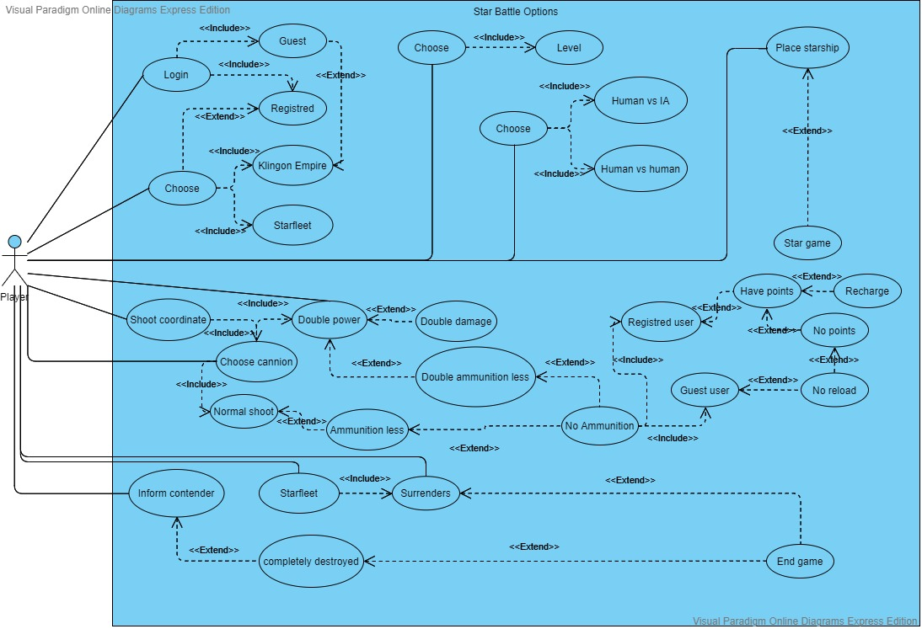

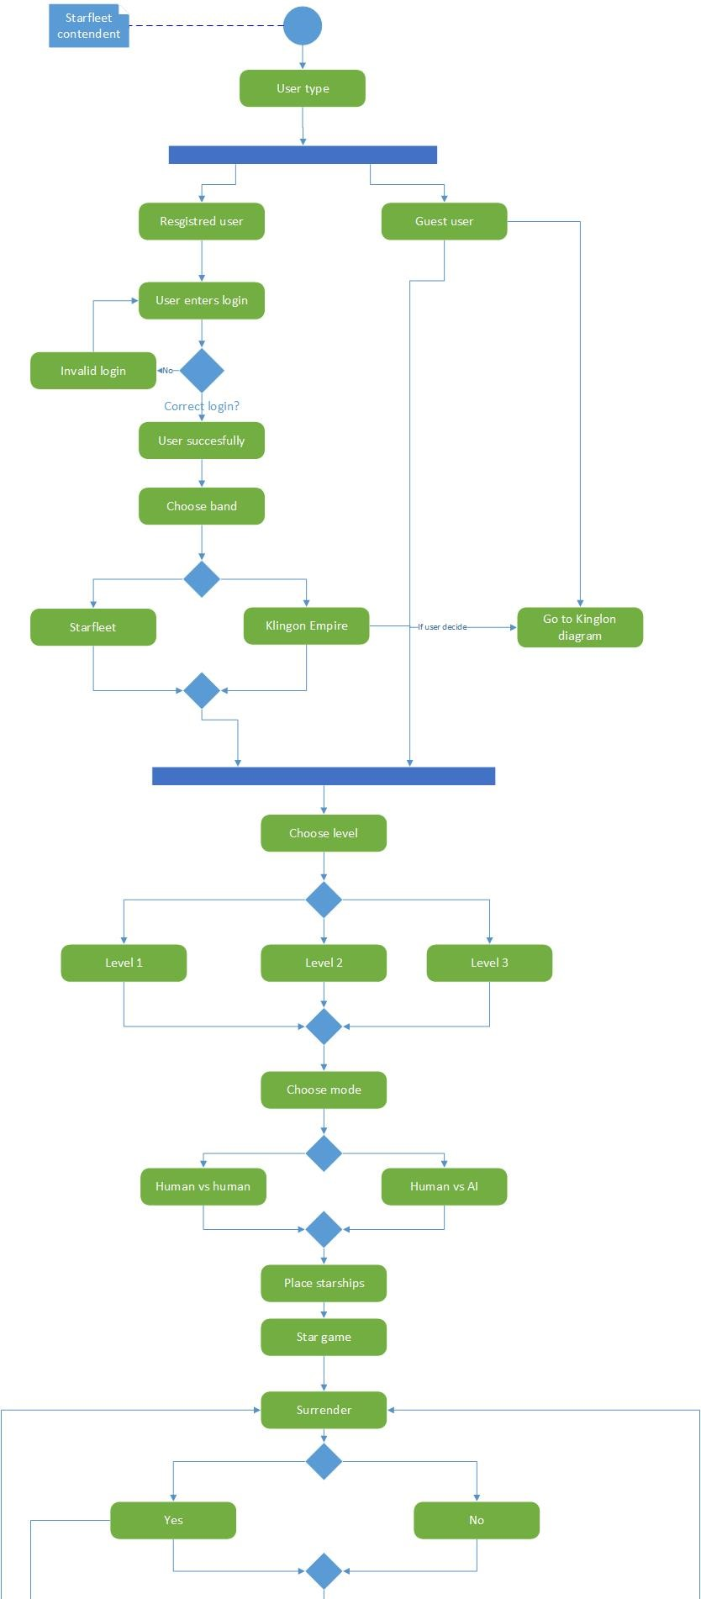

Activity diagrams

Use case Starfleet player
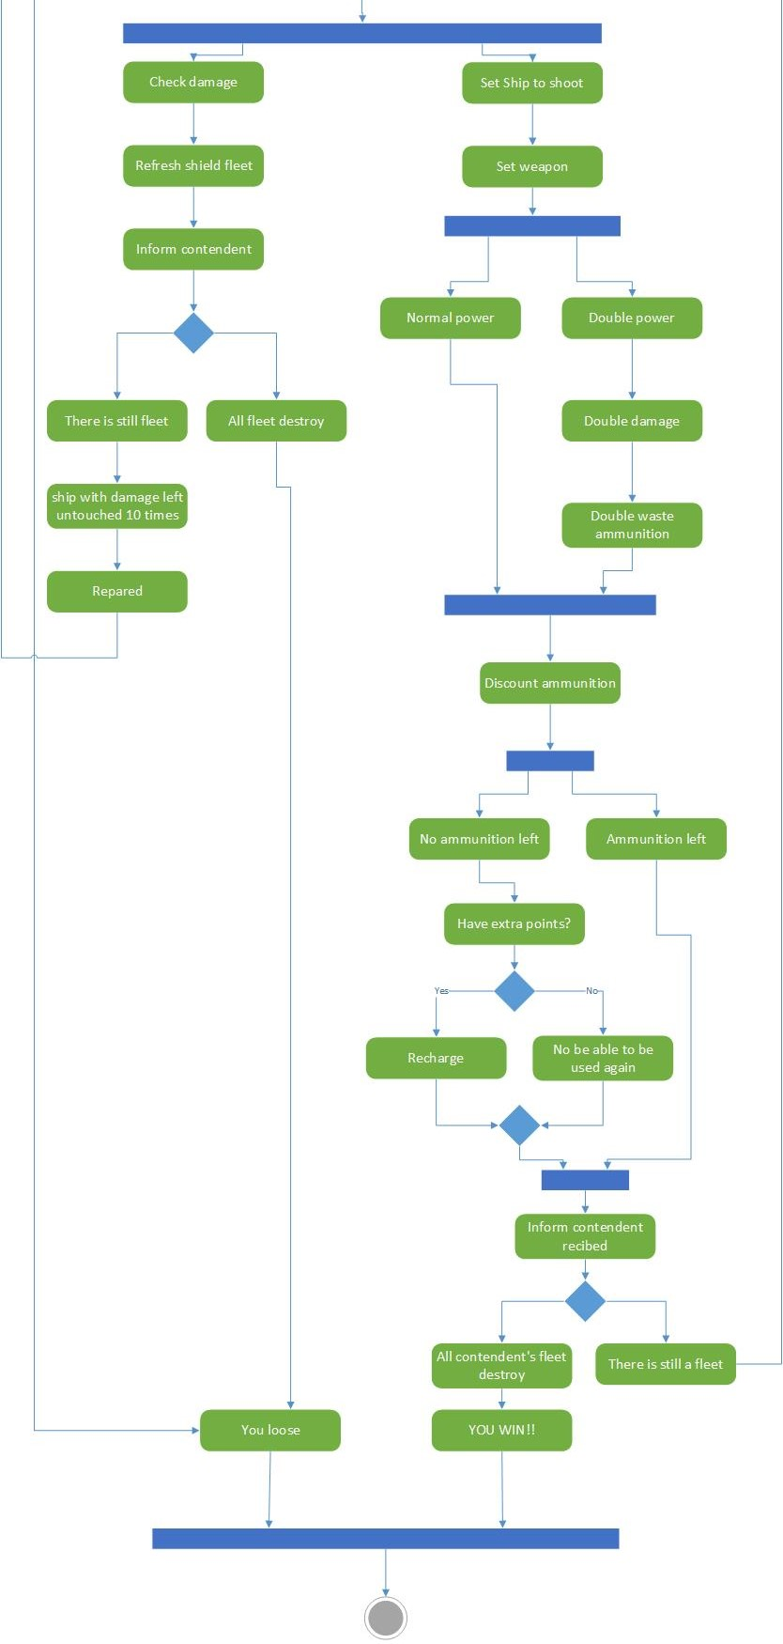

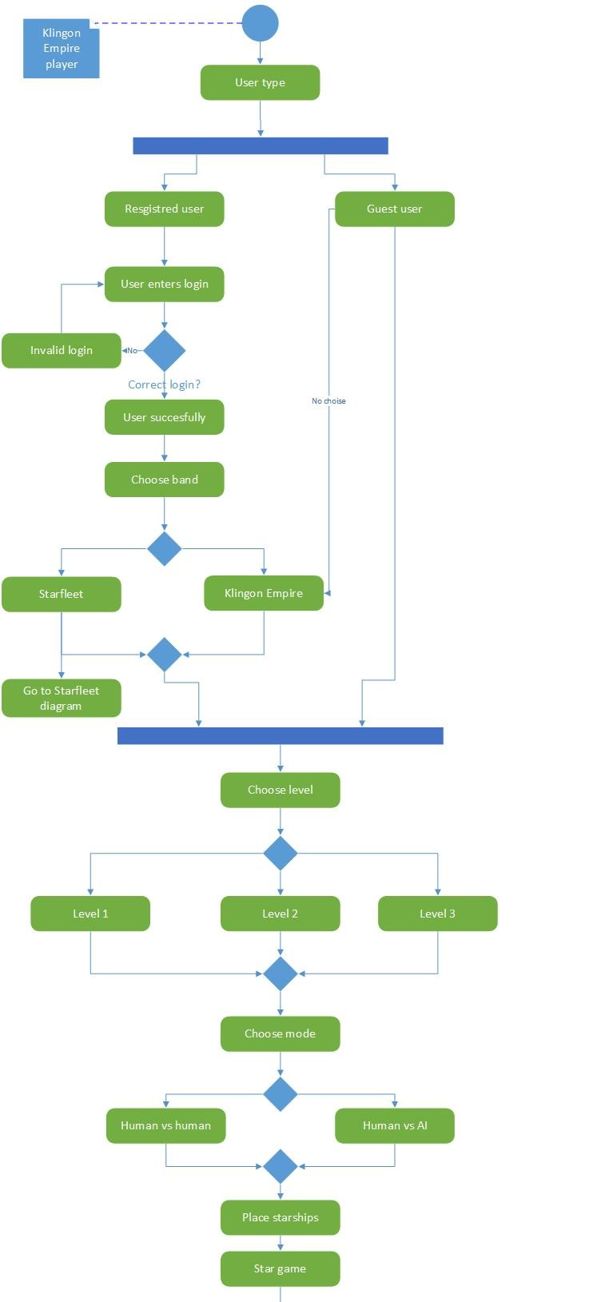
Use case Klingon player

